Lab 08 – Programming Basys 3 board

Name; Sualeh, Abdullah, Haider | Board: DAF305B | Section: T2

Objectives

After performing this lab, student should be able:
- To synthesize bitstream for Basys-3 FPGA board
- Program Basys 3 FPGA board for adder-subtractor design
- Get exposure to design constraint files.

This lab consists of four different sections. The description of each section is given below:

Section | 
- Introduction  In this section, you will be introduced to Basys 3 board and Vivado Design Suite. | 20
- Creating design modules and test bench on Vivado Design Suite  In this section, you will simulate AND gate module using Verilog on Xilinx Vivado and verify the results | 40
- Programming Basys 3 FPGA board  In this section, you will program Basys 3 FPGA board for AND gate design. | 40
- Exercise  In this section, you will test your proposed adder-subtractor system design on FPGA. | 50

Introduction

The Basys 3 board (refer Figure 8. 1) is a complete, ready-to-use digital circuit development platform based on the latest Artix®-7 Field Programmable Gate Array (FPGA) from Xilinx®.
It includes a large collection of on-board I/O devices such as, switches, LEDs, push buttons, seven segment display, and all required FPGA support components. This allows a large number of designs to be completed without the need for any additional hardware. The board is further explained in Video Tutorial 3 uploaded on Canvas.
It is exclusively designed for the Vivado® Design Suite, a software suite produced by Xilinx for synthesis and analysis of HDL designs, with additional features for system on a chip development and high-level synthesis.

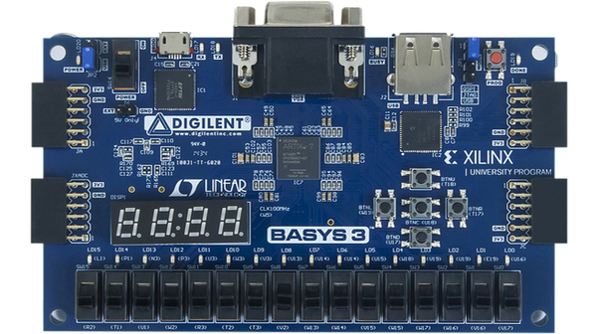
Figure 8. 1 Basys 3 FPGA board

Creating design modules and testbench on Vivado Design Suite

Xilinx Vivado helps to test Verilog designs before uploading it on FPGA. Use myAND module already created in lab 05 and test your simulation.

Reference: Follow tutorial video 1 & 2 and simulate and_gate logic design on Vivado Design Suite.

Attach screenshot of timing diagram of AND gate here.
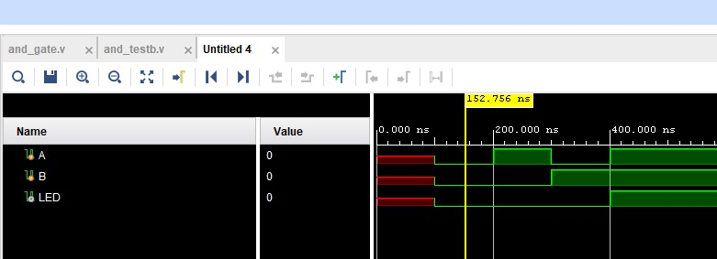
FOR A=0, B=0:
OUTPUT=0

FOR A=0, B=1:
OUTPUT=0

FOR A=1, B=0:
OUTPUT=0

FOR A=1,B=1:
OUTPUT=1

Programming Basys 3 FPGA board

Follow video tutorial 3 to program Basys 3 board for and_gate design.

SWITCHE 1 IS OFF AND 2 IS ON: OUTPUT=OFF
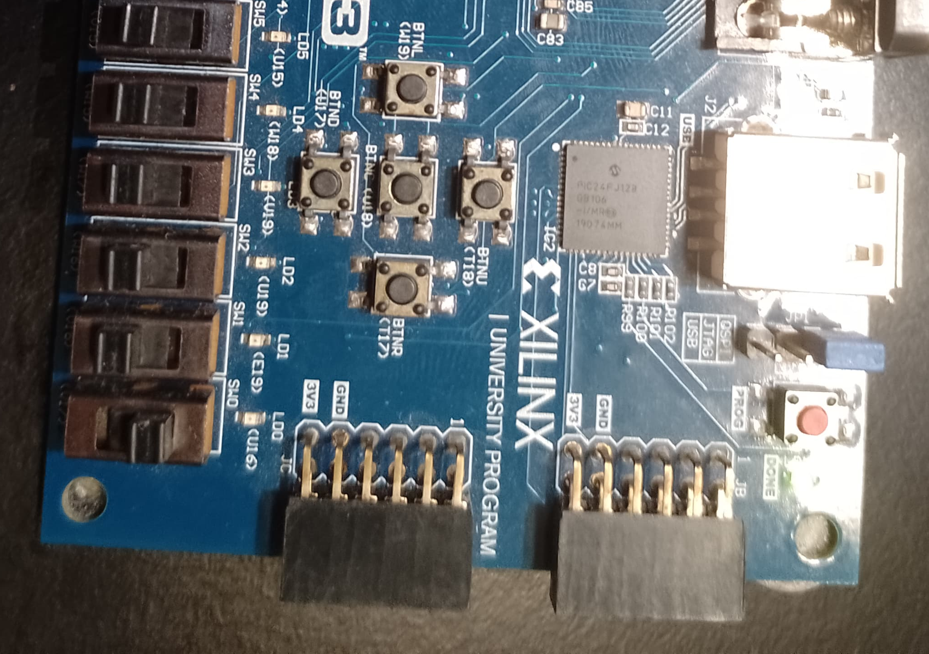

BOTH SWITCH ARE OFF, OUTPUT=OFF
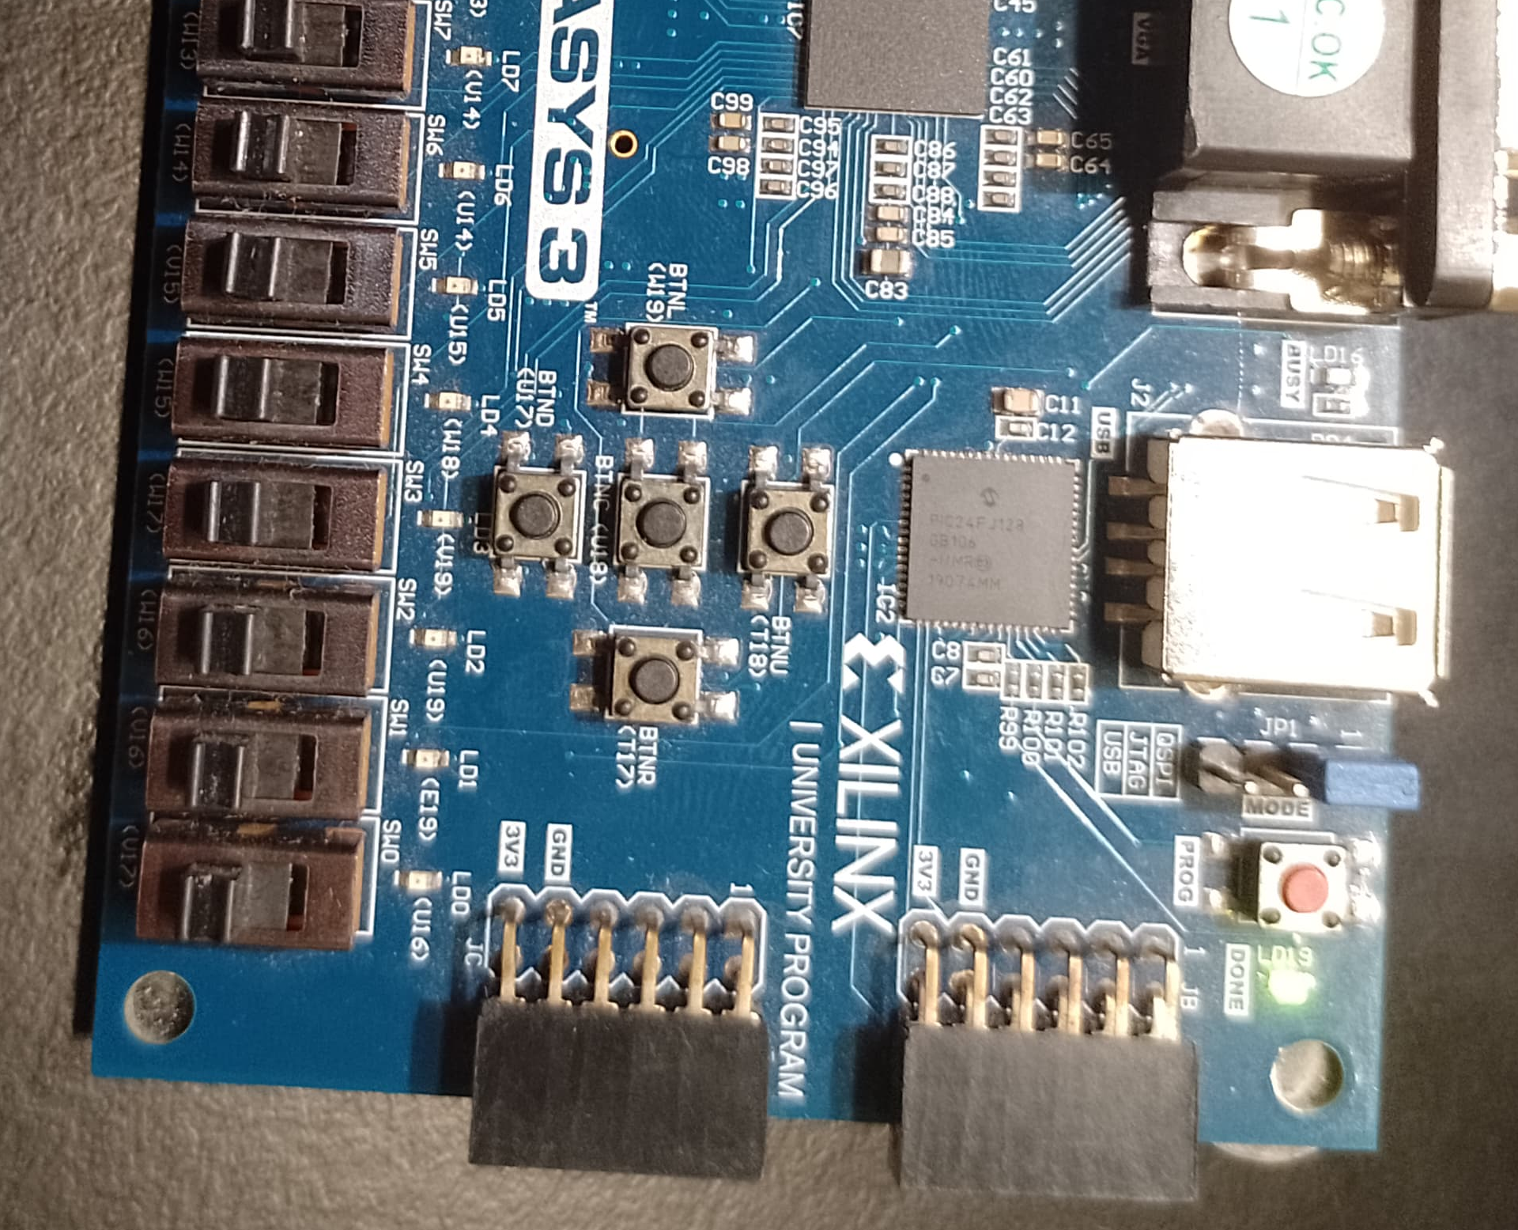

Both switches are ON, Output is ON
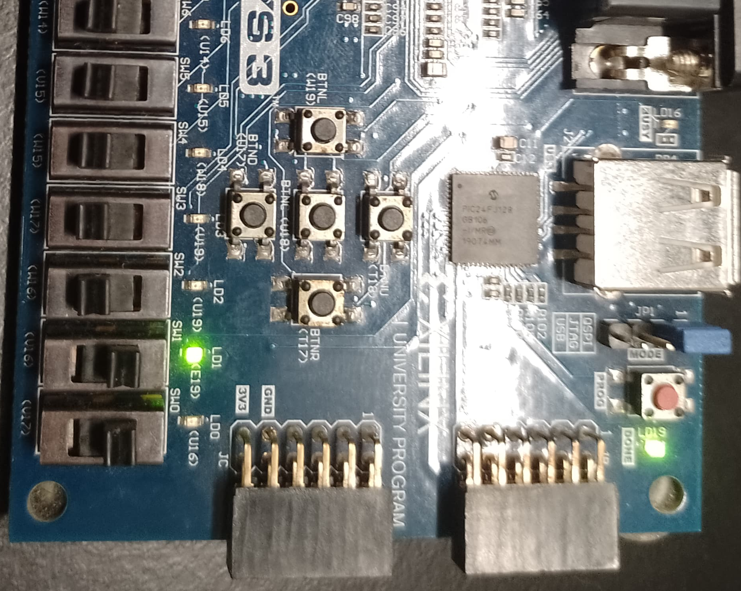

Demonstrate the programmed FPGA to your respective RA.

Testing adder/subtractor design on FPGA

The board has 4-digit seven segment display each activates with an active low signal. As per our design requirement, we need one seven segment display. Thus, one of the displays should be activated and others should remain inactive. In yours add/subtract design module, add one more 4-bit output for seven segment display activation. Send a low signal on one of them and keep rest as high.

Follow the steps listed below or the video tutorials to program the Basys 3 board for your proposed adder/subtractor design. Consider inputs are applied using slide switches and output is displayed on a seven-segment display.
- In Vivado 2020.1 IDE, Create New Project (You can use your project created in previous Lab).
- Create/add design modules as source files.
- Create/add test bench as simulation file.
- Run the simulation to verify your design.
- Next, run synthesis.
- Update .xdc file according to your design.
- Run implementation.
- Generate bitstream and program the device.

 | Add your design files as source files to Vivado project.
 | Make sure the file name is same as module name.
 | A single file can have only one design module.
 | For each user-defined module instantiation in main design, double check the instanced module file is in the same directory as the main design is.

Use Basys 3 user manual (uploaded on Canvas) for pins configuration of seven segment and slide switches.
Demonstrate the programmed FPGA to your respective RA.

Schematic
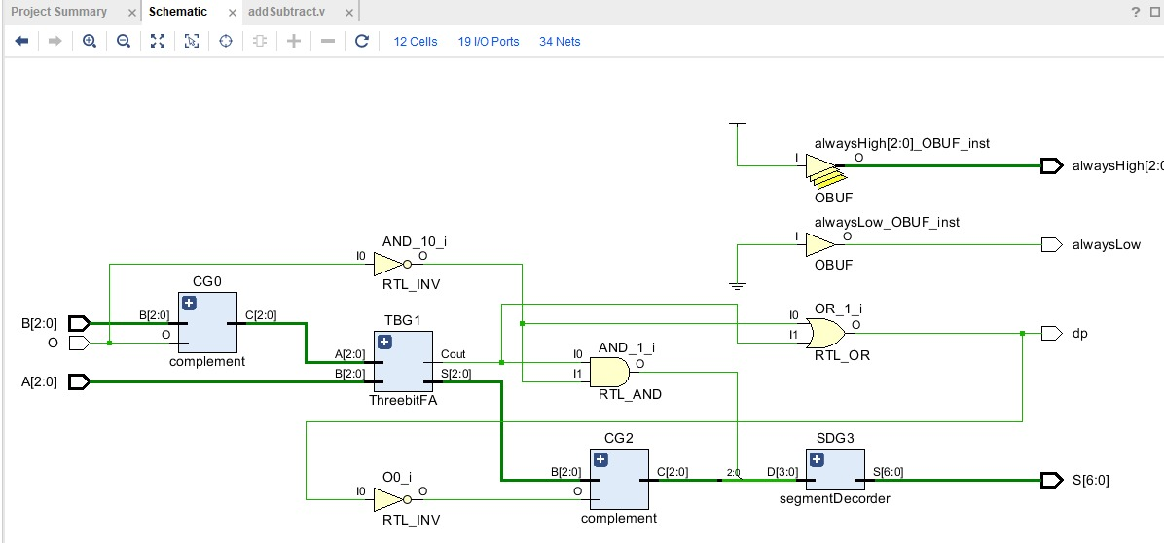

MODULE CODE:
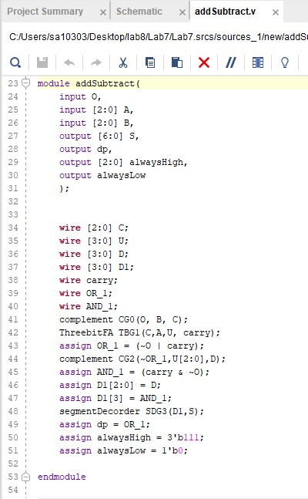

TEST BENCH OF MODULE:
module addSubtract_tb;
reg O;
reg [2:0] A;
reg [2:0] B;
wire [6:0] S;
wire dp;
wire [2:0] alwaysHigh;
wire alwaysLow;
addSubtract uut (
.O(O),
.A(A),
.B(B),
.S(S),
.dp(dp),
.alwaysHigh(alwaysHigh),
.alwaysLow(alwaysLow)
);

initial begin
O = 0; A = 3'b000; B = 3'b000;
#10;
// Test Case 1
O = 0; A = 3'b011; B = 3'b001;
#10;
O = 0; A = 3'b101; B = 3'b010;
#10;

// Test Case 2: Subtraction Mode (O = 1)
O = 1; A = 3'b011; B = 3'b001;
#10;

O = 1; A = 3'b110; B = 3'b010;
#10;
end
endmodule
Board number check:- DAF305B
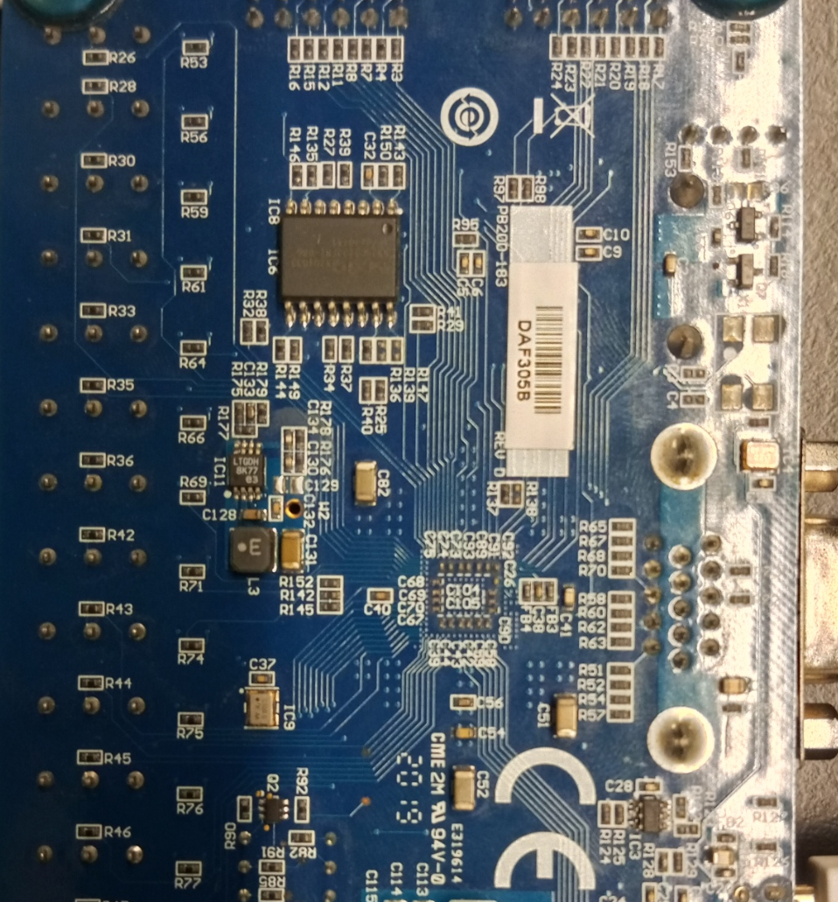

TESTING:

TEST 1: A=1, B=4 SUBTRACTOR (COMPLIMENT) RESULT=3

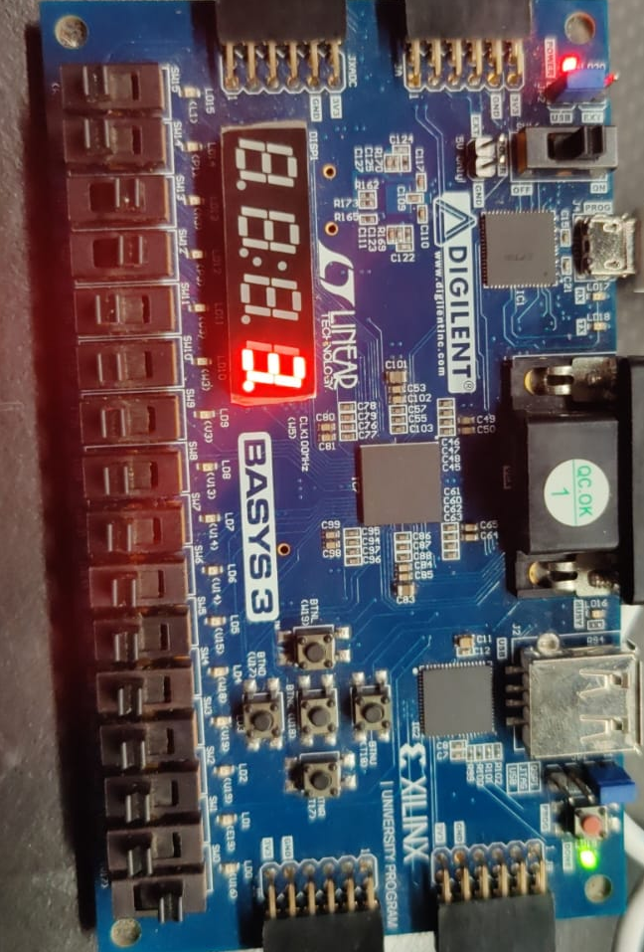

TEST 2: A=2, B=0. ADDITION RESULT= 2

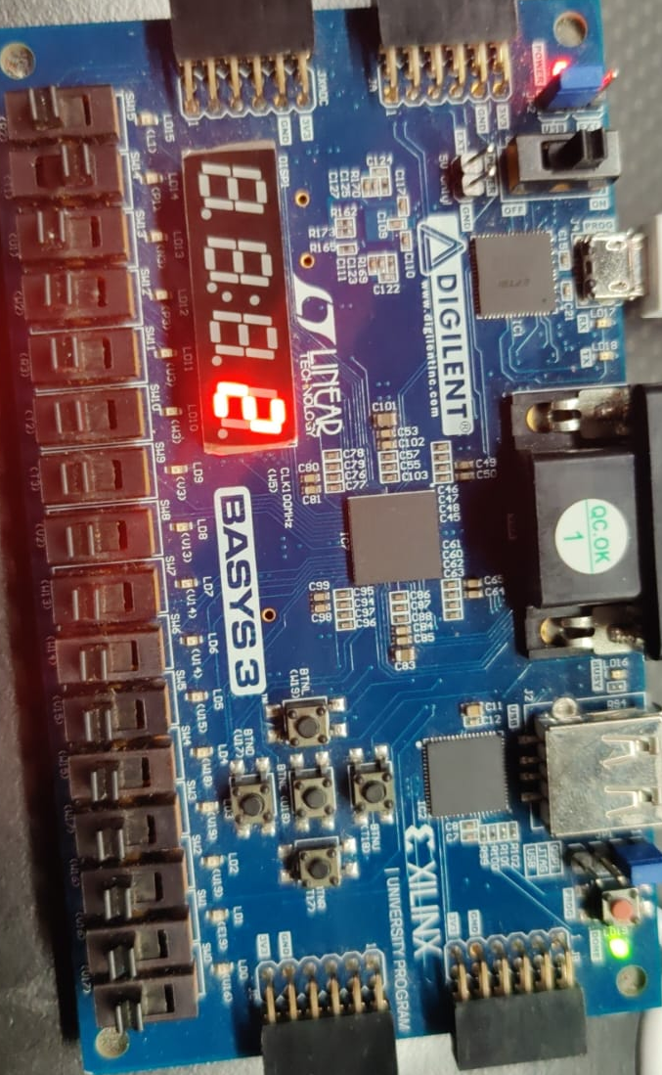

TEST 3: A=5, B=2 ADDITION; RESULT=7

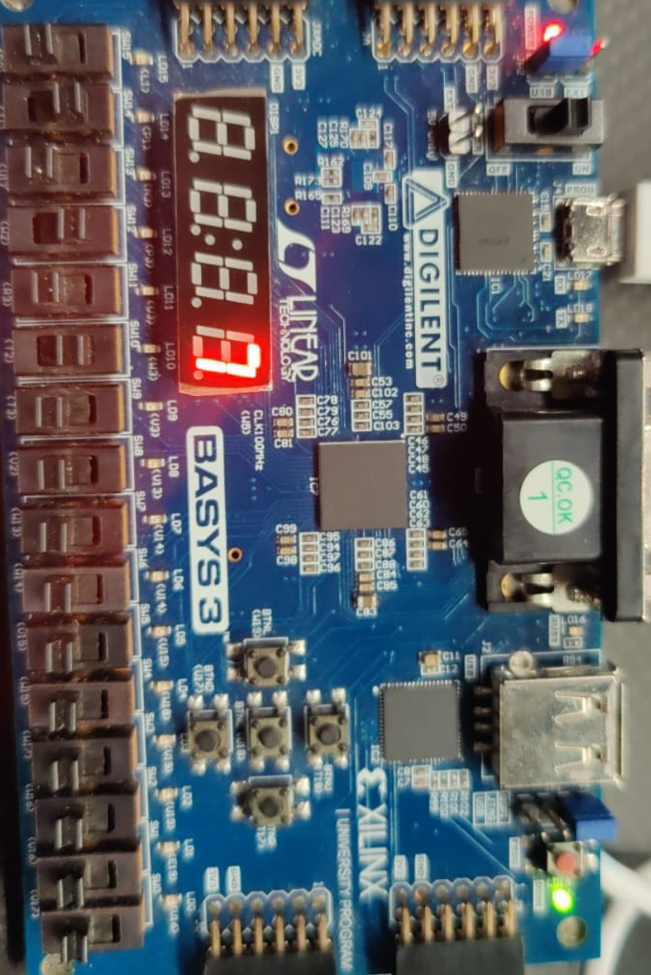

TEST 4: A=4, B=1. ADDITION, RESULT = 5

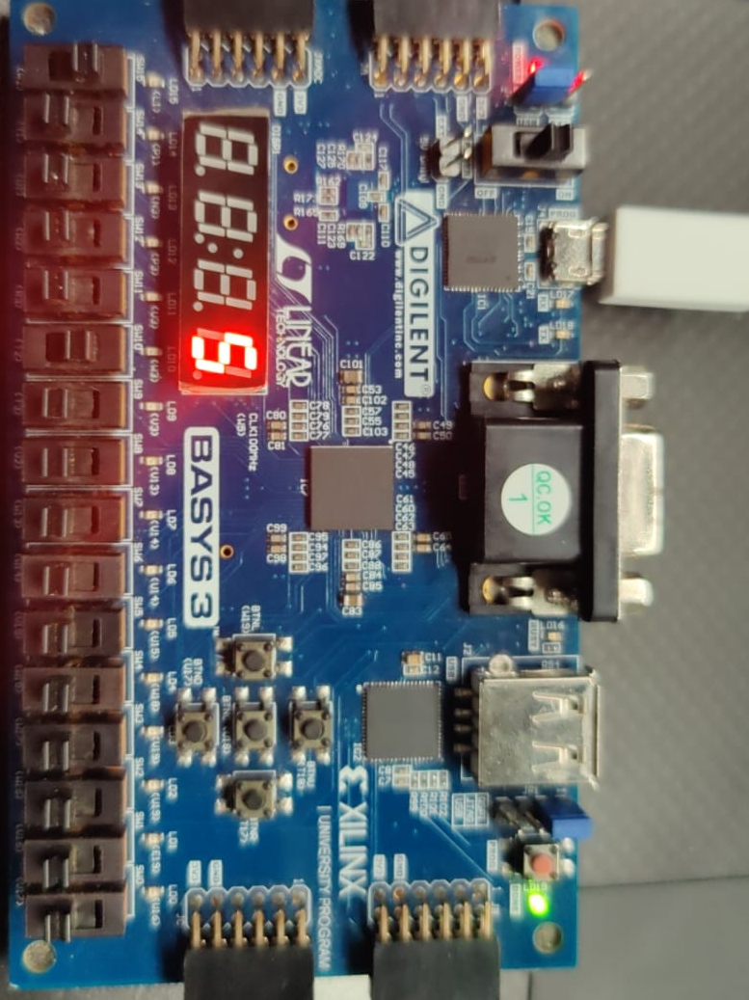

Assessment Rubrics

Marks Distribution:

 |  | LR2  Code/Simulation (In-Lab) | LR5  Results | LR7  Viva | LR9  Report
In-lab | Task b | - | 10 points | 10 points | 10 points
In-lab | Task c | - | 10 points | 10 points | 10 points
In-lab | Task d | 20 points | 10 points | 10 points | 30 points
Total marks 100 |  | 20 | 30 | 10 | 40

Marks Obtained:

 |  | LR2  Code/Simulation (In-Lab) | LR5  Results | LR7  Viva | LR9  Report
In-lab | Task b | -
In-lab | Task c | -
In-lab | Task d
Total marks 100

Lab Evaluation Rubrics
# | Assessment Elements | Level 1: Unsatisfactory | Level 2: Developing | Level 3: Good | Level 4: Exemplary
LR2 | Program/Code/ Simulation Model/ Network Model | Program/code/simulation model/network model does not implement the required functionality and has several errors. The student is not able to utilize even the basic tools of the software. | Program/code/simulation model/network model has some errors and does not produce completely accurate results. Student has limited command on the basic tools of the software. | Program/code/simulation model/network model gives correct output but not efficiently implemented or implemented by computationally complex routine. | Program/code/simulation /network model is efficiently implemented and gives correct output. Student has full command on the basic tools of the software.
LR5 | Results & Plots | Figures/ graphs / tables are not developed or are poorly constructed with erroneous results. Titles, captions, units are not mentioned. Data is presented in an obscure manner. | Figures, graphs and tables are drawn but contain errors. Titles, captions, units are not accurate. Data presentation is not too clear. | All figures, graphs, tables are correctly drawn but contain minor errors or some of the details are missing. | Figures / graphs / tables are correctly drawn and appropriate titles/captions and proper units are mentioned. Data presentation is systematic.
LR7 | Viva | Response shows a complete lack of understanding of the assigned / completed task | Response shows shallow understanding of the assigned task | Response shows substantial understanding of the assigned task | Response shows complete understanding of the completed task. The student is able to explain all the related concepts.

